**Introduction:**

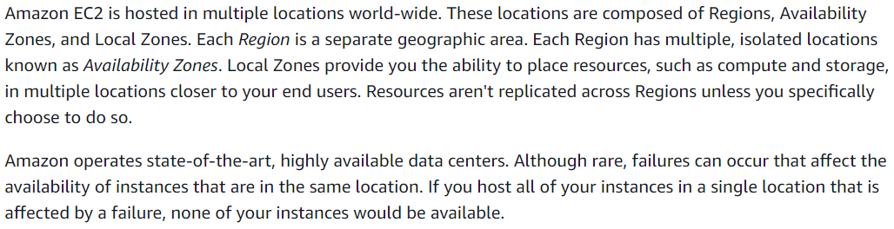

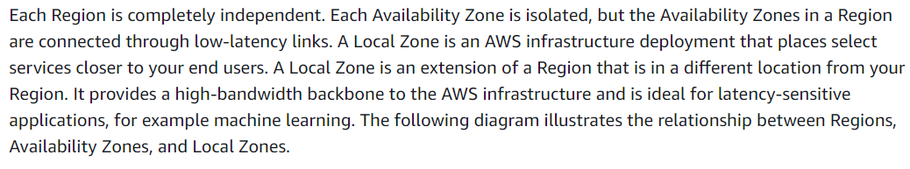

**Regions:**

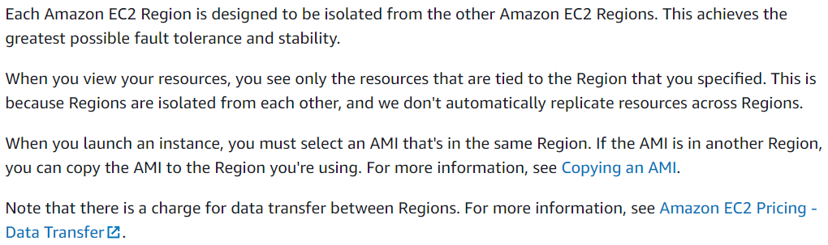

**There won’t be any data replication between the regions**

**Availability zones:**

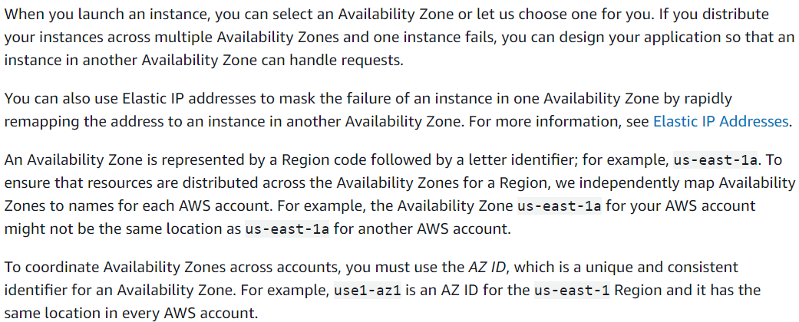

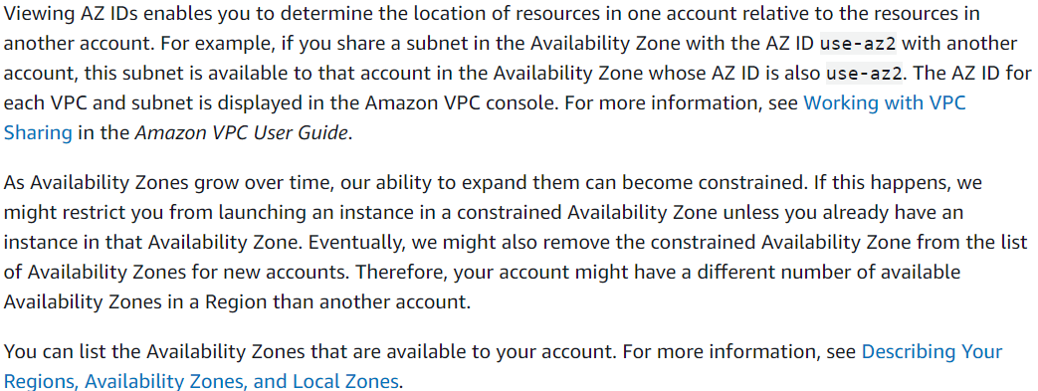

**Local zones:**

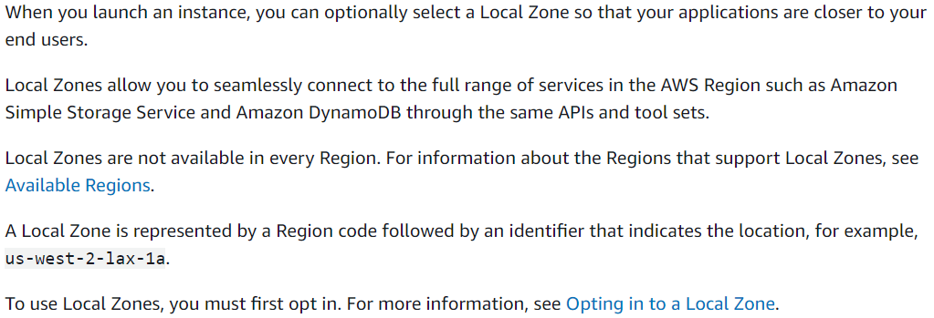

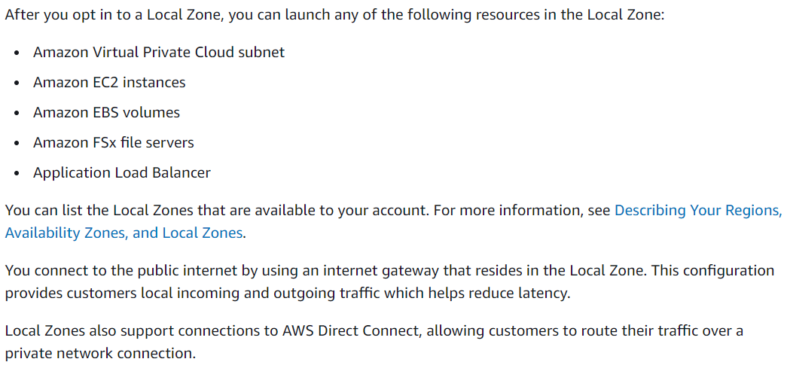

* We can view the availability zones in EC2 dashboard
* When we launch the instance, we better select the default availability zone so that amazon can select the best availability zone for the instance